Mathematics 3A

Examination

Section Two:
Calculator-assumed

Time allowed for this section
Reading time before commencing work: 10 minutes
Working time for this section: 100 minutes

Material required/recommended for this section
To be provided by the supervisor
This Question/Answer booklet
Formula sheet (retained from Section One)

To be provided by the candidate
Standard items: pens, pencils, pencil sharpener, eraser, correction fluid, ruler, highlighters

Special items: drawing instruments, templates, notes on two unfolded sheets of A4 paper, and up to three calculators satisfying the conditions set by the Curriculum Council for this examination

Important note to candidates
No other items may be used in this section of the examination. It is your responsibility to ensure that you do not have any unauthorised notes or other items of a non-personal nature in the examination room. If you have any unauthorised material with you, hand it to the supervisor before reading any further.

Structure of this paper

Section | Number of questions available | Number of questions to be answered | Working time (minutes) | Marks available
Section One:  Calculator-free | 7 | 7 | 50 | 40
Section two: Calculator assumed | 8 | 8 | 100 | 80
 |  |  |  | 120

Instructions to candidates

1. The rules of conduct of school exams should be known to you. Sitting this exam implies you agree to abide by these rules.

2. Write your answers in the spaces provided in this Question/Answer Booklet. Spare pages are included at the end of this booklet. They can be used for planning your responses and/or as additional space if required to continue an answer.
- Planning: If you use spare pages for planning, indicate this clearly at the top of the page
- Continuing an answer: If you need the space to continue an answer, indicate in the original answer space where the answer is continued, i.e. give the page number. Fill in the number of the question(s) that you are continuing to answer at the top of the page.

3. Show all your working clearly. Your working should be sufficient to allow your answers to be checked readily and for marks to be awarded for reasoning. Incorrect answers given without supporting reasoning cannot be allocated any marks. For any question or part question worth more than two marks, valid working or justification is required to receive full marks. If you repeat an answer to any question, ensure that you cancel the answer you do not wish to have marked.

4. It is recommended that you do not use pencil except in diagrams.

SectionTwo: Calculator-assumed

This section has eight (8) questions. Answer all questions. Write your answers in the space provided.

Spare pages are included at the end of this booklet. They can be used for planning your responses and/or as additional space if required to continue an answer.
- Planning: If you use spare pages for planning, indicate this clearly at the top of the page
- Continuing an answer: If you need the space to continue an answer, indicate in the original answer space where the answer is continued, i.e. give the page number. Fill in the number of the question(s) that you are continuing to answer at the top of the page.

Suggested working time for this section is 100 minutes.

Question 8 (11 marks)

(a) Calculate the mean, median, mode and standard deviation for the data represented in this graph: (4 marks)

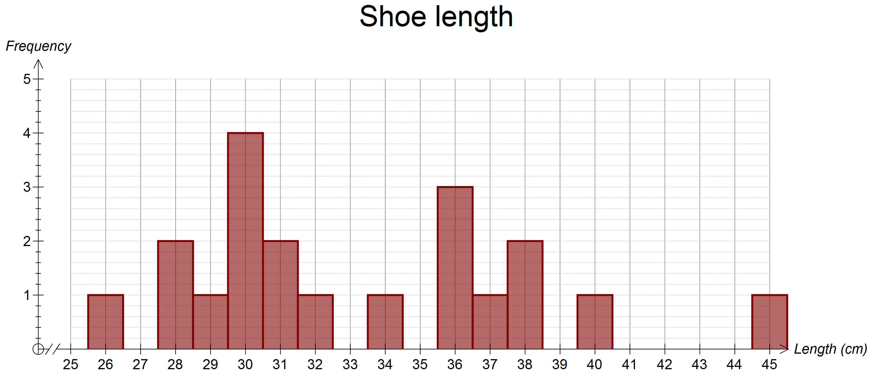

Mean = 33.25, median = 31.5, mode = 30 and sd = 4.84 [1 mark each]

(b) Draw a box and whisker plot to represent this set of data. (5 marks)

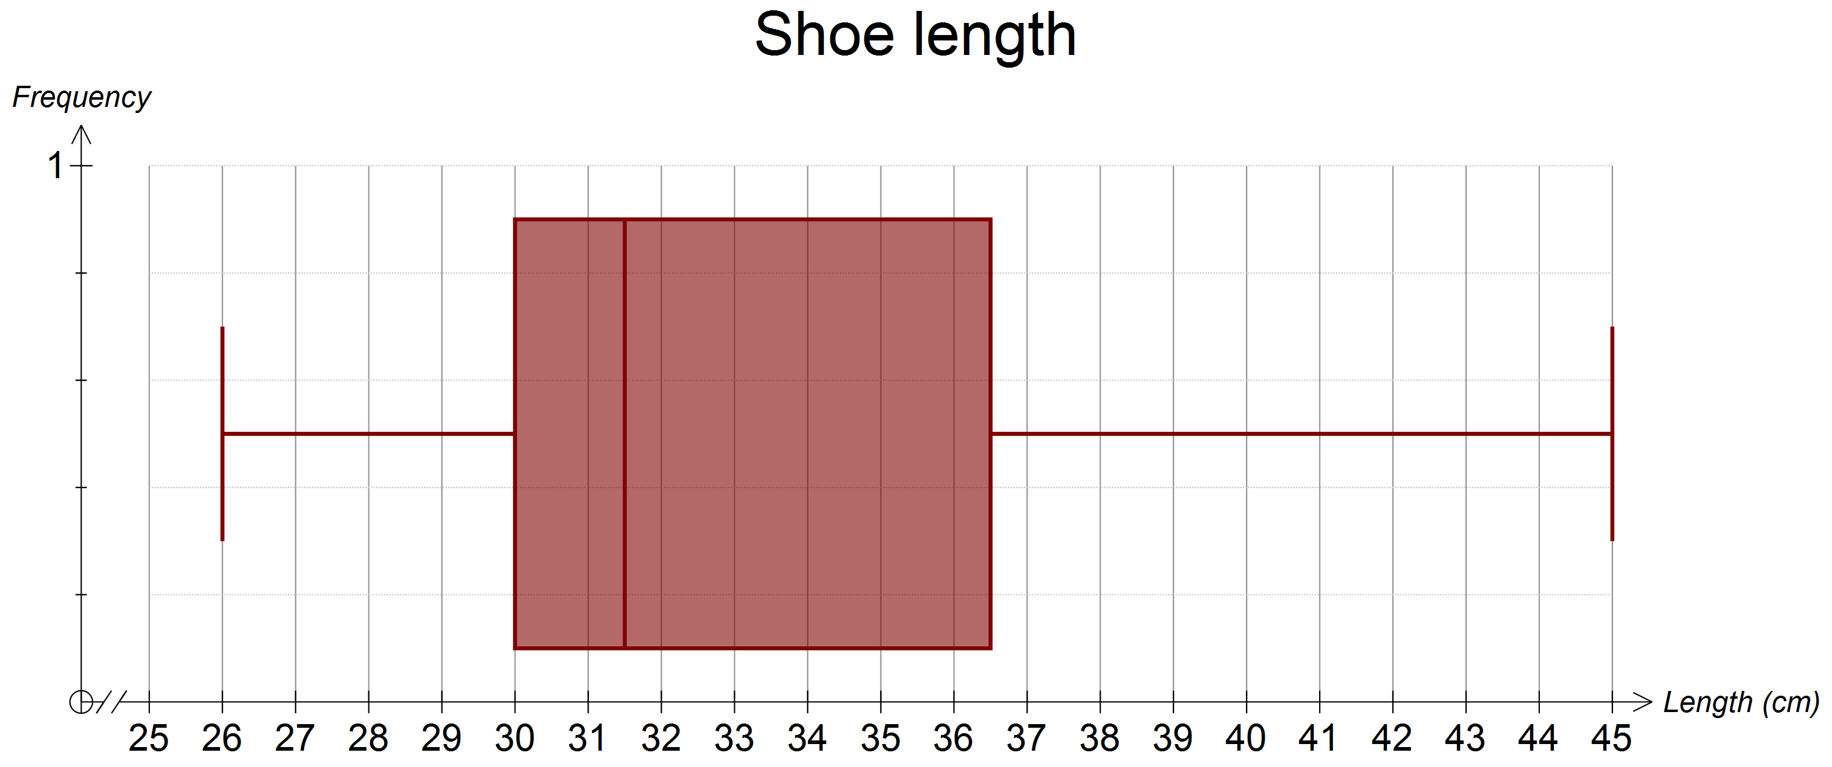 [5]

(c) Comment on any outliers in this data explaining your comments. (2 marks)

Outliers are identified as being more than 1.5 × IQR beyond the quartiles.
i.e. above 36.5 + 9.75 = 46.25 or below 30 − 9.75 = 20.25
This means no values would be considered outliers. [2]

Question 9 (9 marks)

(a) Calculate the missing values, (i) to (vii), in the following spreadsheet: (7 marks)

Month | Amount owing | Interest | Repayment | Balance
1 | (i) | $191.67 | $1,000.00 | $19,191.67
2 | $19,191.67 | $183.92 | $1,000.00 | $18,375.59
3 | $18,375.59 | $176.10 | $1,000.00 | $17,551.69
4 | $17,551.69 | (ii) | $1,000.00 | (iii)
5 | (iv) | (v) | $1,000.00 | $15,880.12
6 | $15,880.12 | $152.18 | $1,000.00 | $15,032.31
7 | $15,032.31 | $144.06 | $1,000.00 | $14,176.37
8 | $14,176.37 | $135.86 | $1,000.00 | $13,312.22
9 | $13,312.22 | $127.58 | $1,000.00 | $12,439.80
10 | $12,439.80 | $119.21 | $1,000.00 | $11,559.01
11 | $11,559.01 | $110.77 | $1,000.00 | $10,669.79
12 | $10,669.79 | $102.25 | $1,000.00 | $9,772.04
13 | $9,772.04 | $93.65 | $1,000.00 | $8,865.69
14 | $8,865.69 | $84.96 | $1,000.00 | $7,950.65
15 | $7,950.65 | $76.19 | $1,000.00 | $7,026.84
16 | $7,026.84 | $67.34 | $1,000.00 | $6,094.19
17 | $6,094.19 | $58.40 | $1,000.00 | $5,152.59
18 | $5,152.59 | $49.38 | $1,000.00 | $4,201.97
19 | $4,201.97 | $40.27 | $1,000.00 | $3,242.24
20 | $3,242.24 | $31.07 | $1,000.00 | $2,273.31
21 | $2,273.31 | $21.79 | $1,000.00 | $1,295.09
22 | $1,295.09 | $12.41 | $1,000.00 | $307.50
23 | $307.50 | $2.95 | (vi) | (vii)

(i) $20,000.00 (ii) $168.20 (iii) $16.719.89 (iv) $16,719.89
(v) $160.23 (vi) $310.45 (vii) $0 [1 mark each = 7]

(b) What is the interest rate used in the spreadsheet? (2 marks)

11.5% p.a. or 0.95835% per month [2]

Question 10 (8 marks)

An insurance company produced the following table from 2360 clients to investigate different age groups claims for road accidents in a year:

 | Age of driver
Number of accidents | ≤20 years | 21 – 30 years | 31 – 40 years | 41 – 50 years
0 | 125 | 138 | 247 | 450
1 | 218 | 223 | 133 | 116
2 | 174 | 162 | 94 | 74
>2 | 93 | 87 | 16 | 10
Total:

What is the probability that a driver chosen at random:

(a) Had more than 2 accidents? (1 mark)

(93 + 87 + 16 + 10)/2360 = 206/2360 = 0.087 [1]

(b) Is 21 to 30 years of age? (1 mark)

(138 + 223 + 162 + 87)/2360 = 610/2360 = 0.258 [1]

(c) Is 20 years or less and had only one accident? (1 mark)

218/2360 = 0.092 [1]

(d) Had no accidents? (1 mark)

(125 + 138 + 247 + 450)/2360 = 960/2360 = 0.407 [1]

(e) Had no accidents if she or he was 31 to 40 years of age? (2 marks)

247/(247 + 133 + 94 + 16) = 247/490 = 0.504 [2]

(f) Was 41 to 50 years if he or she had 2 accidents? (2 marks)

74/(174 + 162 + 94 + 74) = 74/504 = 0.147 [2]
Question 11 (14 marks)

(a) Draw a graph here showing the following two functions over the domain: 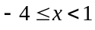.

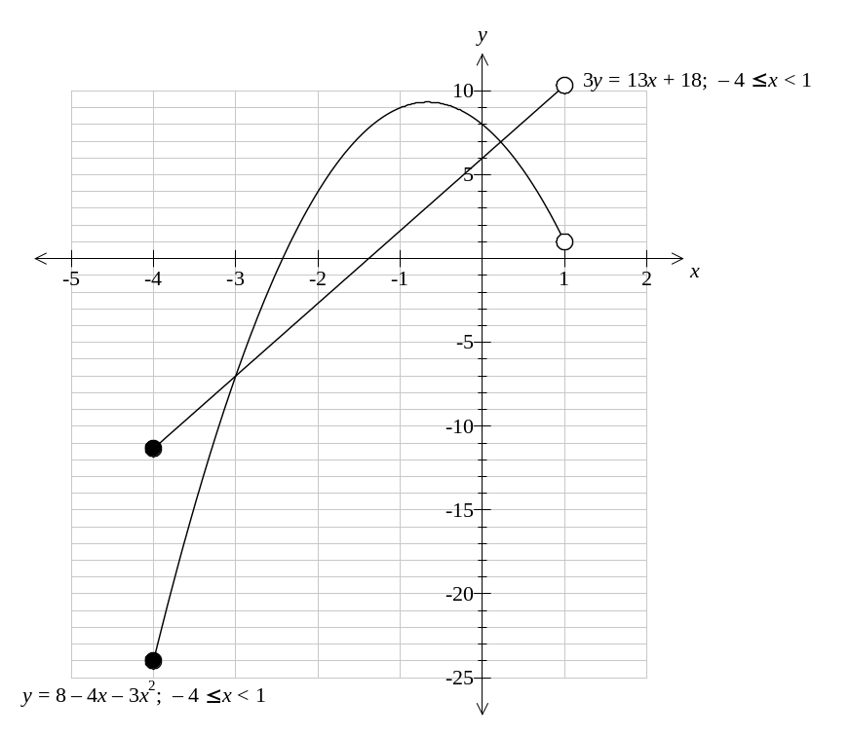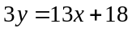 and 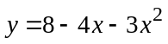 (6 marks)

[Each graph 2 marks and domain 2 marks = 6 marks]

(b) From the graph find an exact solution to and . (2 marks)

(-3,-7) [2]

(c) Show verification that your solution is an exact solution. (2 marks)

One way is 3(-7) = (-21) = 13(-3) + 18 and (-7) = 8 − 4(-3) − 3(-3)² [2]

(d) Estimate another solution to the simultaneous equation from your graph. (2 marks)

About (0.2,6.9) [2]

(e) Refine this other solution accurate to three decimal places. (2 marks)

(0.22,6.963) [2]
Question 12 (9 marks)

The diagram below shows a piece of land with some known measurements.

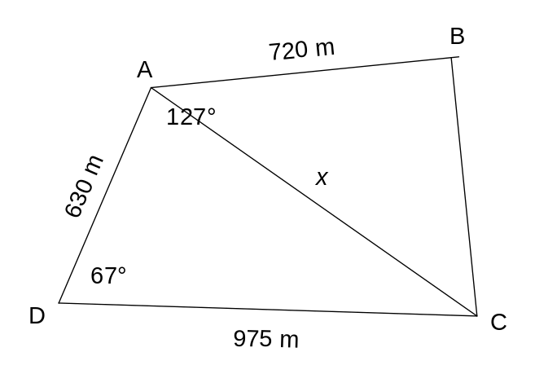

Calculate the area of this piece of land in hectares showing all working. Your working must include the calculation of the length of a diagonal and the use of the formula 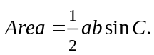

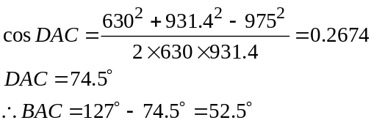

Total area = 282 710 + 266 015 = 548 725 m² = 54.8725 ha

[Allocate part marks to stages – dependant on method used – eg 2 for Area ADC, 2 for x, 2 for angle BAC, 1 for area BAC, 1 for total area, 1 for hectares]
Question 13 (9 marks)

A machine is set to fill packets of potato chips with 200 g of chips. However, due to the inaccuracy of this type of machine the actual weights in packets are normally distributed with a mean of 201 g and a standard deviation of 4.5 g. A quality control measure used by the factory is to weigh each packet after filling and recycle any packet with less than 195 g.

(a) What percentage of packets will be recycled? (4 marks)

N (201,4.5²) P(X<195) = P(Z<-1.33) = 9.12% [4]

(b) If the factory produces 12000 packets per day how many will be recycled in one day?
(2 marks)

12,000 × 0.091211 = 1095 [2]

(c) If a packet is selected from those destined for recycling what is the probability that its weight is less than 190g? (3 marks)

P(X<190 |X<195) = P(Z<-2.44 | Z<-1.33) = 0.007254/0.091211 = 0.07953 [3]

Question 14 (8 marks)

(a) A 100g block of ice melts losing 15% of its mass every hour. (5 marks)

(i) Write down its mass initially i.e. 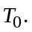
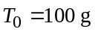 [1]

(ii) Write down its mass after 1 hour i.e. 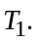
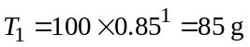 [1]

(iii) Write down 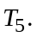
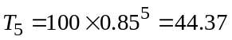 [1]

(iv) Write down a recursive formula for 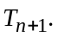
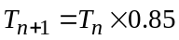 [2]

(b) Find 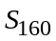 of a sequence given 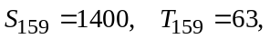 and the recursive rule for the sequence is 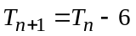 (3 marks)

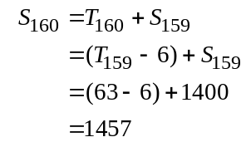
[3]

Question 15 (12 marks)

Given the graph below of the function 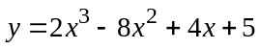:

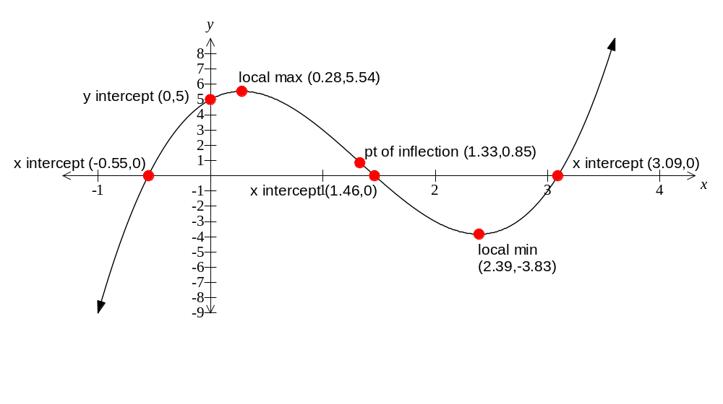

(a) Label the following: (3 marks)

(i) intercept/s [1 mark for all four labeled as per above]

(ii) turning point/s [1 mark for all four labeled as per above]

(iii) point/s of inflection [1 mark for all four labeled as per above]

(b) Use your calculator to give values for all of these labeled points accurate to two decimal places or exactly if possible.
(4 marks)
[4 marks with a mark off for each omission or error as per above]

(c) Use your values to solve the equation 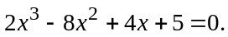 (3 marks)

x = -0.55, 1.46, 3.09 [1 mark each]

(d) Explain how to derive solutions to the equation 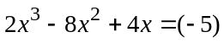 from the graph above.
(2 marks) is equivalent to 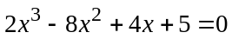 hence the solutions are the same. [2]

Additional working space

Question number(s): _____________
Additional working space

Question number(s): _____________

Additional working space

Question number(s): _____________

